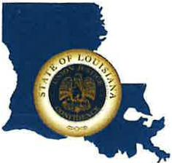 | CAPITAL AREA GROUNDWATER CONSERVATION DISTRICT
GARY I. BEARD
EXECUTIVE DIRECTOR

MEETING NOTICE
Capital Area Groundwater Conservation District Meeting
Board Meeting

WHEN: Thursday, June 30, 2022

TIME: 10:30 a.m.

WHERE: LA State Capitol
900 North St.
House Committee Room 5
Baton Rouge, LA 70802

Contact Person: Lisa Manda, (225) 293-7370

